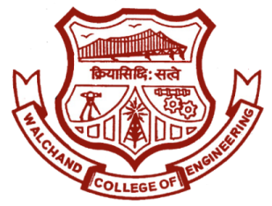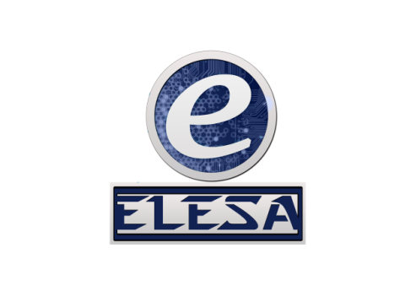

WALCHAND COLLEGE OF ENGINEERING, SANGLI

**ELESA**

**ELECTRONICS ENGINEERING STUDENTS’ ASSOCIATION**

Email: [walchand.elesa@gmail.com](mailto:walchand.elesa@gmail.com) Website: [www.elesa.in](http://www.elesa.in)

**Date:- 07/4/2018**

**SECRETARIAL REPORT ON**

**PROTEUS WORKSHOP**

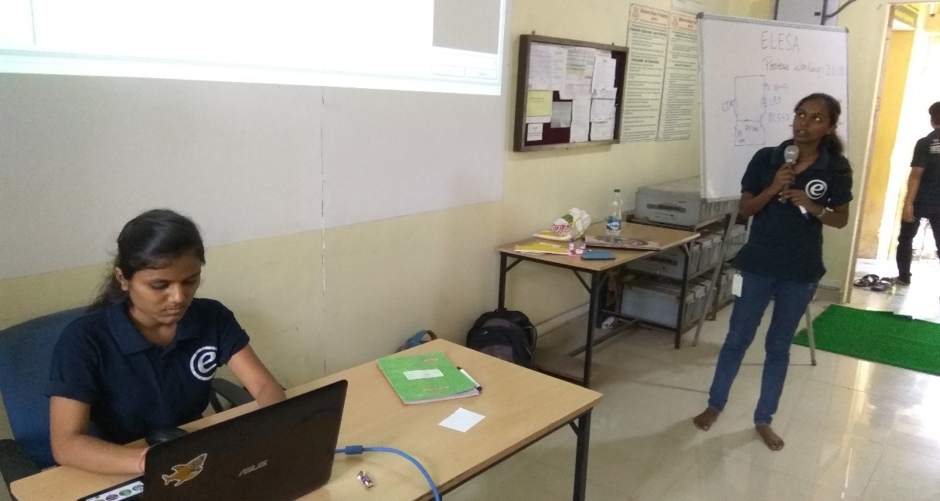Every year ELESA organized PROTEUS workshop for First year students and carrying the same tree forward Assistant Board of ELESA organized PROTEUS workshop for First Year Students of Electrical and Electronics Stream. Workshop was organized for 2 days on 7th and 8th April 2018 from morning 8:00 a.m. to 6:00 p.m. The very 1st day workshop took place for Electronics branch from which 50 entries were registered and the 2nd day workshop took place for Electrical branch from which 27 entries were registered.

Basically Proteus is a simulation software of electrical circuits virtually before mounting on hardware. The software comes of immense use for Electrical and Electronics Stream students in their upcoming years and the moto of the event was to make them familiar with the software. Organizing Committee had their topics divided among themselves which they conveyed to the students with sheer enthusiasm on both of the days.

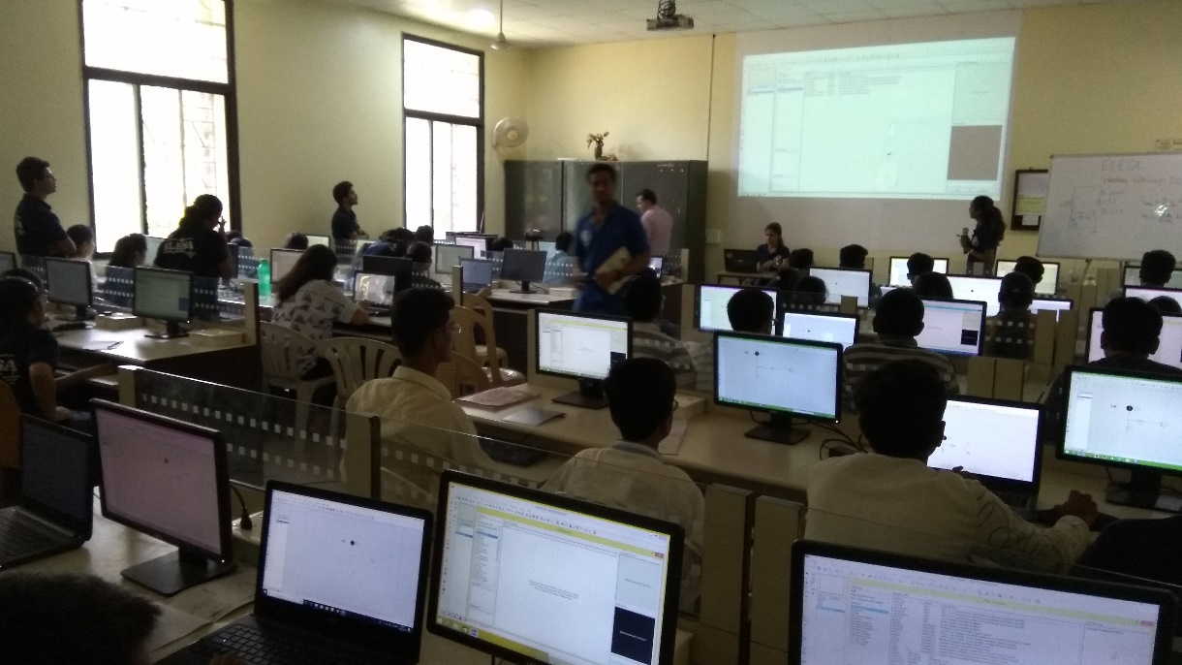

Students were provided with refreshment two times to keep them active. A test was taken in the end on respective days to judge them by T.Y. Members on the basis of which grade was assigned to them on the certificate and were distributed to them and with this the event concluded.

Mr. Ajit Attarde

Joint secretary,

ELESA